**Student Retention Analytics Tool**

Team Echo

Adam Carrigan, James Gilligan, Cody Lepp,  
Adam Mason, Karen Ross, and Dratin Wood

CSC480A Computer Science Capstone Project I

Project Proposal

National University, San Diego, CA

Winter 2023

Dr. Albert Cruz

**Contents**

1.0 Introduction 3

1.1 Project Team 3

2.0 Background and the Need for the Project 4

3.0 Project Objectives and Scope 4

3.1 Project Objectives 4

3.1.1 Data Analysis: 5

3.1.2 Actionable Insights 5

3.1.3 Data Pipeline Optimization 6

3.1.4 Integration 6

3.2 Scope 6

3.2.1 Limited Focus 6

3.2.2 Exclusion of Business Growth Metrics 6

3.2.3 Non-Interference 6

4.0 Customers and Stakeholders 7

4.1 Stakeholders 7

4.2 Customers 7

5.0 Project Requirements 7

5.1 Functional Requirements 7

5.2 Non-Functional Requirements 8

5.3 High-Level Use Case Scenarios 8

5.3.1 User Registration and Authentication Performance expectation: Quick registration process and fast login/authentication (within seconds). 8

5.3.2 Teachers identify the most at-risk student/s and prioritize tasks and resources appropriately. 9

5.3.3 Disenrollment from the program. 9

5.3.4 Teachers pull a report of their students to see if they are close to the application’s at-risk threshold. 9

6.0 Project Assumptions and Constraints 10

6.1 Project Assumptions 10

6.2 Project Constraints 10

6.3 Project Priorities 10

7.0 Project Delivery Methods 11

7.1 Delivery Expectations 11

7.2 Customer Requirements for System Deployment 11

7.2.1 Hardware Specifications 11

7.2.2 Software Dependencies 11

7.2.3 Security Measures 11

8.0 Project Issues and Risks 12

9.0 Evaluation, Selection of Technology and Tools for Project Implementation 14

10.0 Product Backlog: Prioritized Feature List and Effort Estimates (hrs.) 14

11.0 Initial Architecture Design 14

12.0 Agile Team Formation, Responsibilities, and Implementation Iterations (schedule)14

12.1 Team Responsibilities 14

12.2 Iteration Plan 15

13.0 Conclusion15

References 15

Appendix 15

Attachments, if any. 15

List of Abbreviations 15

Definitions 15

# Introduction

This capstone project focuses on enhancing student retention across different educational institutions by developing a specialized *student retention analytics tool (SRT)*. Each educational institution, regardless of its nature, faces the perpetual challenge of fostering an environment where students not only remain but also thrive and stay engaged in their educational journey.

The core aim is to create an analytics tool that can sift through data to identify key factors influencing student retention. This involves analyzing attendance patterns, learning progress, and feedback to understand what keeps students engaged and where they face challenges. The tool will use gathered data to provide insights, project corrections, and recommend actions to educators and staff, enabling them to optimize their teaching methods.

By leveraging data analytics, the project seeks to bridge the gap between traditional teaching methods and modern, data-driven approaches. The goal is to enhance the learning experience for students, making it more engaging and effective, which in turn, is expected to improve retention rates. This project is not just about understanding the current state of student engagement at diverse educational institutions but also about laying a foundation for continuous improvement in teaching and learning strategies in the field of education.

## Project Team

*Adam Carrigan* - Program tester and data analyst with a background spanning aerospace mechanics, property management, sales, and entrepreneurship. This diverse skill set brings a unique blend of technical and business skills to the team.

*James Gilligan* - Data analyst with a background in airborne sensors and weapon systems, unmanned aerial systems, Naval Special Warfare, and counter-unmanned systems development. As a member of a combat development directorate, James has experience with generating and analyzing requirements.

*Cody Lepp* - Software engineer, and concept designer. Contributions include customer interfacing, requirements engineering, technical writing, algorithm design and analysis, machine learning modeling, and project management.

*Adam Mason* - Data analyst with a background in customer service/help desk, information technology, cybersecurity, auditor, Lean Six Sigma (LSS), and instructor. Skills in both customer service and LSS help bring process improvement ideologies and cybersecurity methods, helping strengthen the system’s security architecture.

*Karen Ross* - Scrum Master with proficiencies in C++, Java, SQL, and Python. Additionally, I serve as a data analyst and software developer. My contributions revolve around overseeing the *SRT* project, ensuring seamless coordination among team members, and maintaining workflow.

*Dratin Wood* - Software developer with a background in customer service, data management, and information systems. Experience in application development for small-scale projects provides valuable insights and is instrumental in ensuring the alignment of project outcomes with customer needs.

# Background and the Need for the Project

In the field of supplementary education, the need for student retention is especially crucial for organizations that offer extracurricular academic support. These institutions focus on empowering students to excel in various subjects, making it essential to provide academic assistance and comprehend and address any factors that might impact their ongoing engagement. Understanding these elements is vital to ensuring that students continue to benefit from these educational resources.

Traditional methods of gauging student progress, such as manual tracking of attendance and academic performance, prove insufficient for identifying nuanced patterns that may signal potential disengagement. Recognizing this challenge, our proposed software engineering project seeks to develop an adaptable analytics tool tailored to suit diverse educational institutions. This tool will harness the available data on attendance, performance, and engagement to provide actionable insights aimed at enhancing student retention.

The paramount significance of this project lies in its capacity to significantly enhance student retention rates within the confines of the existing resources and curriculum employed. Our tool will equip educators and administrators with the essential information required to employ highly targeted interventions by unveiling patterns and identifying students at risk of disengagement.

Our tool will also acknowledge the influential role of parental preference in student retention. Recognizing that continued enrollment often hinges on the desire of students to participate, our analytics tool will aim to align the institution’s assistance with student preferences. Additionally, the adaptability of the tool will ensure that, as students progress through the curriculum, support strategies can be tailored to accommodate the evolving needs of students at every stage. This comprehensive approach not only strengthens the company's efforts in student retention but also underscores our commitment to addressing the multifaceted dynamics that contribute to the success of the educational institution.

# Project Objectives and Scope

## Project Objectives

The *Student Retention Analytics Tool* project is a crucial initiative to develop a sophisticated analytics solution tailored to *any* educational organization. The primary objective of this tool is to analyze the critical factors influencing student retention within the organization and provide actionable insights for targeted interventions. The secondary objectives, data pipeline optimization and integration within an existing organizational information system will enhance the capabilities of synthesizing actionable insights through data analysis.

By leveraging advanced analytics, machine learning models, and the latest data visualization trends, this project aims to provide educational institutions with a comprehensive understanding of the factors contributing to student retention and attrition, enabling the organization to make data-driven decisions and develop effective interventions to support student success.

### Data Analysis

Conduct a comprehensive analysis of existing student data, including attendance, performance, and engagement metrics. Identify patterns and trends that may indicate potential dropouts or areas for improvement. By following the steps outlined below, we aim to extract actionable insights.

* Data Collection
* Data Cleaning
* Exploratory Data Analysis
* Data Transformation
* Statistical Analysis
* Modeling (regression, classification, clustering)
* Model Evaluation and Validation

### Actionable Insights

Develop a software application that translates the analyzed data into actionable insights for tutors and business leaders. These insights will empower institutions to implement targeted retention strategies based on individual student needs. The project will incorporate machine learning models and advanced analytics techniques to derive meaningful recommendations for tutors and business leaders including:

* Modeling
  + Logistic Regression
  + Ensemble Learning (Random Forests)
  + Time Series Analysis
  + Clustering
* Training and Validation
* Feature Importance Analysis
* Prediction and Classification
* Insight Generation
* Visualization
* Continuous Monitoring and Updating

### Data Pipeline Optimization

Identify, aggregate, and optimize the data pipeline to ensure efficient and accurate analysis of retention metrics. Streamline collecting and processing data to provide timely and relevant insights. The following objectives will be included in this process:

* User-Friendly Interface
* Automated Data Updates
* Data Gathering
* Data Cleaning and Transformation
* Data Integration

### Integration

Seamlessly integrate the preexisting data and the new *Student Retention Analytics Tool*. Ensure the software application is user-friendly and aligns with operational workflow.

## Scope

The scope of this project is expressly defined to address the retention challenges within various educational institutions and does not extend beyond the following boundaries:

### Limited Focus

The project is solely focused on developing a *Student Retention Analytics Tool* and will **not** encompass the creation of a general business analytics solution. However, the same data that is used for existing business intelligence analysis can be supplied to the *SRT* models to produce useful insights.

### Exclusion of Business Growth Metrics

The tool will **not** provide explicit metrics related to overall business growth. Its primary function is to analyze and improve student retention with a targeted approach toward individual student success.

### Non-Interference

The *SRT*  will complement existing strategies and operational processes of educational institutions. Its implementation will be designed to integrate harmoniously into existing organizational information systems – without disruptions.

By adhering to these objectives and scope limitations, the project aims to deliver a specialized SRT that enhances educational institutes ability to proactively address student retention challenges and foster a more effective learning environment.

# Customers and Stakeholders

## Stakeholders

*Educational Administrators and Tutors:* The administrators and tutors are key stakeholders who will directly use *SRT*. They will benefit from the insights the tool generates to implement targeted interventions, thereby improving student retention.

*Marketing Team:* The marketing team is a crucial stakeholder as they may use insights from the tool to refine marketing strategies. Understanding factors contributing to student retention enables educational institutions to attract and retain students strategically and temporally.

*Sales Team:* The sales team may benefit from insights into what aspects of the program contribute most to student retention. This knowledge can be used to better communicate the value of educational institutions to potential customers.

*Executives/Leadership:* The executive leaders within the educational institution are strategic stakeholders as they are responsible for the overall success and alignment of the project with the company's goals. They may use the insights generated from the tool to make informed decisions about resource allocation, business strategy, long-term trajectories, and institutional adjustments

*Parents:* Parents receive tailored guidance and recommendations to aid their child’s academic development, empowering them to make informed decisions about their child’s education while fostering collaboration between home and the educational institution.

*Students*: Students benefit from targeted help that suits their unique learning styles, helping them address weaknesses and reinforce strengths in their academic journey.

## Customers

Our project has defined the *customers –* the primary users of the *SRT –* to be the following stakeholders:

*Educational Institutions:* The primary users of *SRT*  are the administrative staff within the educational institution. The customer will use *SRT* frequently to determine the status of each of their students. The analytics tool will provide actionable insights from the metrics that deter or garner the support of parents who decide to continue enrollment. Educational institutions will further drive the implementation, interface, support, and various planning aspects of the software package.

*Educational Instructors:* The secondary users of this tool will be the tutors and administrators who use the insights to encourage and target students who are struggling or need some motivation to continue their journey at the institution.

# Project Requirements

## Functional Requirements

F01: The system must have access to student academic data already available in the learning center’s database.

F02: The system must allow users to view student progress.

F03: The system must allow users to report when a student has disenrolled or expressed a desire to disenroll from the program.

F04: The system must retain historical student data, even if the student is removed from the program. This data will be used for trend analysis. Any personally identifiable information (PII) will be scrubbed from this record.

F05: The system must analyze attendance and academic progression data of disenrolled students for trend analysis.

F06: The system must use historical trends to identify when a student is at risk of disenrollment.

F07: The system must notify users of an at-risk student and risk factors (attendance, academic progress, engagement, etc.).

F08: The system must share resources with applicable faculty members.

F09: The system must provide users with student data to arrange for parent/teacher meetings.

F10: The system must model and predict future enrollment with accuracy within a predefined threshold.

## Non-Functional Requirements

NF01: The system shall have a simple, easy-to-use user interface.

NF02: The system shall use cybersecurity best practices to ensure student data is protected.

NF03: The system shall notify users of at-risk students the morning after the determination is made.

NF04: The application shall load and process data in a reasonable time frame.

NF05: The system should be able to handle an increasing volume of student and user data without compromising performance or security.

NF06: The system shall be OS agnostic.

NF07: The system shall not unintentionally aggregate data of different students.

## High-Level Use Case Scenarios

### User Registration and Authentication Performance expectation: Quick registration process and fast login/authentication (within seconds).

* + - 1. *Scenario*: A user logs into the analytics dashboard to view all student progress.
      2. *Scenario*: An admin user filters the students by various attributes such as time at the institution, progress percentage, name, age, grade, level, etc.

### Teachers identify the most at-risk student/s and prioritize tasks and resources appropriately.

At-risk students are sorted by time in risk-based status and how far behind they are

* + - 1. *Scenario*: An administrator sees three students in the ‘*at risk*’ category on their login screen. (1) Joe is a student on day one of being ‘at risk’. (2) Sally has *been* ‘at-risk’ for one month, but progress is improving. (3) Susie is at the threshold of ‘*non-risk*’ and has been in ‘at-risk’ for three months. The administrator looks at the list, and the system automatically categorizes the students based on risk level. The administrator takes action from the list and reaches out to the respective student. The risk level indicates to the administrator who should take priority.

### Disenrollment from the program.

* + - 1. *Scenario*: The student has been disenrolled from the program. The teacher must remove the student profile and alert the application of the disenrollment so the relevant data can be stored and analyzed.

### Teachers pull a report of their students to see if they are close to the application’s at-risk threshold.

* + - 1. *Scenario*: The teacher wants to prevent students from becoming ‘at risk’ students. The teacher accesses the database, pulls the class records, and adjusts the output to show students near the threshold.
      2. *Scenario*: Image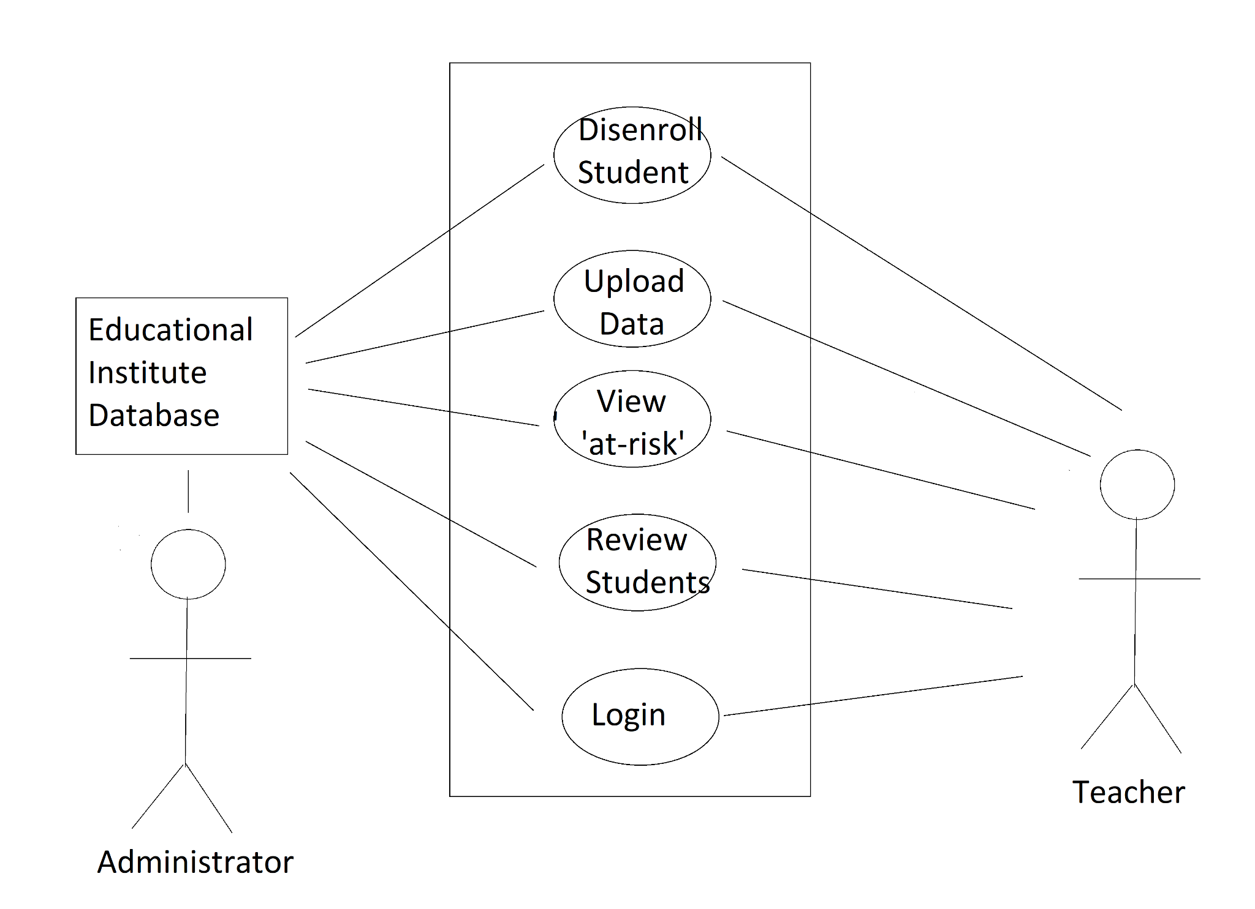

# Project Assumptions and Constraints

## Project Assumptions

* User Engagement: Assumption that the target users (students, educators, and after-school program coordinators) will actively engage with the application.
* Data Availability: Assuming access to relevant and accurate student performance and engagement data from educational institutions.
* Stakeholder Availability: Assuming availability and timely input from key stakeholders for decision-making.
* Technology Compatibility: Assuming the chosen technology stack is appropriate for the application's requirements.
* Regulatory Compliance: Assuming compliance with relevant data protection and privacy regulations.
* Requirements: Each educational entity requires tailored retention strategies. Private schools, vocational institutes, and public institutions have distinct focuses, requiring custom recommendations.

## Project Constraints

* Budget: As a school project, this is an unfunded endeavor for all development, testing, and implementation phases.
* Time: Fixed timeline for the project completion, considering academic calendars and program schedules.
* Staffing: Availability of skilled personnel, potential skill gaps, or resource constraints.
* Technology Limitations: Constraints related to the technology infrastructure and compatibility with existing systems.

## Project Priorities

* User Experience (UX): Ensuring a user-friendly interface for all types of users to maximize engagement.
* Feature Development: Implementing core features related to student performance, attendance, and engagement tracking as a **top priority.**
* Data Security and Privacy: Prioritizing the implementation of robust security measures to protect sensitive student information.
* Scalability: Designing the application architecture to accommodate future growth and increasing user loads.
* Adaptability: Building flexibility into the application to accommodate changes in educational policies, technologies, and user requirements.
* Quality Assurance: Rigorous testing to ensure the reliability and accuracy of analytics generated by the application.
* Stakeholder Collaboration: Fostering open communication and collaboration among stakeholders.
* Training and Support: Providing adequate training materials and support resources for end-users and program administrators.

# Project Delivery Methods

## Delivery Expectations

The customer anticipates the delivery of the student retention analytics tool in a timely manner, adhering to the agreed-upon project schedule. The system should be delivered incrementally through a website application, allowing continuous feedback and iterative improvements. Regular updates and demonstrations should be provided to keep the customer informed about the project's progress. The final delivery should align closely with the outlined specifications and meet the customer's functionality, usability, and performance expectations.

## Customer Requirements for System Deployment

From the customer's perspective, certain requirements are essential for the successful deployment and operation of the *SRT* within their enterprise environment. These requirements include:

### Hardware Specifications

The customer requires the tool to be OS agnostic. That is, the tool should work on any desktop, laptop, or mobile device. The tool should remain within the specified processing power of the customer's devices. Memory requirements for the tool should not exceed the total capacity of the host system. The user's device's storage capacity should maintain minimal student data storage to ensure optimal performance.

### Software Dependencies

The *SRT* requires access to the customer’s database of students. The simplest way would be to pipe the data from the customer’s database warehouse straight into the web application. The proper credentials must be supplied by the customer to ensure a seamless integration. However, the software should import data through CSV and Excel.

### Security Measures

The data must be secured within the customers' database to keep data integrity throughout the transfer from database to application. The customer must have industry-level authentication protocols, encryption measures, and database security in place prior to deployment.

# Project Issues and Risks

|  | Issue or Risk Brief Detail | Risk Probability | Mitigation Plan | Responsibility | Status: Open, WIP, closed |
| --- | --- | --- | --- | --- | --- |
| 1 | Scope Creep  / Ambiguity | High | Clearly define project scope and obtain sign-off. Regularly communicate project scope boundaries. | Project Manager | Open |
| 2 | Data Security Concerns | High | Implement robust security measures, encryption, and compliance with data protection regulations. Regularly audit and update security protocols. | Data Analyst | Open |
| 3 | Limited Resources & Experience | High | Allocate time for skill development that pertains to the tools needed to accomplish the project. | Project Manager | Open |
| 4 | Scalability Challenges | High | Design the application with scalability in mind, conduct performance testing, and have a plan for scaling infrastructure if needed. | Program Tester | Open |
| 5 | External Dependencies | Medium | Identify alternative APIs or implement fallback mechanisms. Regularly monitor the status of external dependencies. | Project Manager | Open |
| 6 | Unforeseen Technical Issues | Medium | Conduct thorough testing, implement monitoring systems, and have a contingency plan for critical issues. | Program Tester | Open |
| 7 | Quality Assurance and Feedback Incorporation | Medium | Implement feedback sessions and regular testing, use agile development methodologies for iterative improvements and prioritize user experience. | Scrum | Open |
| 8 | Time Management | Low | Develop a realistic project timeline, prioritize tasks, and regularly reassess deadlines based on academic schedules. | Scrum | Closed |
| 9 | Communication Challenges | Low | Establish clear communication channels, conduct regular team meetings, and use collaboration tools. | Scrum | Closed |
| 10 | Team Member Turnover | Low | Cross-train team members on critical tasks. Document processes to ease the transition. | Project Manager | WIP |

# Evaluation, Selection of Technology and Tools for Project Implementation.

Things We Need:

1. SQL Database: MySQL to hold the current student data
2. NonSQL Database: MongoDB
3. GUI built with PyQt6
4. Pandas for data manipulation and ETL procedures.
5. Programming Model built with Python.
6. Website will be built with Django
7. Scikit-learn built machine learning models for analytical insights.
8. Visualization API: Seaborn

# Product Backlog: Prioritized Feature List and Effort Estimates (in 30min. story points)

* User Registration and Authentication System - Estimated Effort: 2 points.
* Data Integration and ETL Processes - Estimated Effort: 3 points.
* Academic Performance Analytics Module (Grades, Coursework Progress, Standardized Test Scores) - Estimated Effort: 3 points.
* Attendance and Participation Tracking System (Overall Attendance, Class Participation) - Estimated Effort: 2 points.
* Behavioral and Engagement Metrics Module (Extracurricular Activities, Social Engagement, Disciplinary Records) - Estimated Effort: 3 points.
* Learning Progress and Milestones Tracker (Curriculum Progression, Skill Development) - Estimated Effort: 3 points.
* Feedback and Interaction Analytics (Teacher Feedback, Parental Involvement) - Estimated Effort: 2 points.
* Psychosocial and Wellness Metrics Monitoring (Well-being Measures, Counselor Interactions) - Estimated Effort: 2 points.
* Demographic and Background Information Module (Age, Socioeconomic Background, Language Proficiency) - Estimated Effort: 2 points
* Technology and Resource Access Tracker (Access to Resources, Digital Engagement) - Estimated Effort: 2 points.
* Post-Secondary Aspirations Tracking (College Applications, Career Planning) - Estimated Effort: 2 points..
* Retention-Specific Metrics System (Enrollment Status, Enrollment Changes) - Estimated Effort: 3 points.
* Risk Identification and Notification System - Estimated Effort: 3 points.
* User Interface for Data Visualization - Estimated Effort: 4 points.
* Student Data Management System - Estimated Effort: 3 points.
* Performance and Scalability Optimization - Estimated Effort: 2 points.
* Security and Compliance Measures - Estimated Effort: 2 points.
* Parent-Teacher Collaboration Features - Estimated Effort: 2 points.
* Feedback and Improvement Module - Estimated Effort: 2 points.
* Documentation and Training Materials - Estimated Effort: 1 point.

Total Estimated Effort: 45 story points.

# Initial Architecture Design

The initial architecture was produced with seven core modules in mind, with an additional two more that allow for scalability and integration.

**Database**

The system's core is a robust and scalable database that stores comprehensive student data, including academic records, attendance, extracurricular activities, and other relevant information that contributes to student retention.

**Analytics Engine**

A powerful analytics engine processes the data from the database to generate insights. This engine employs algorithms and statistical models to identify patterns, trends, and potential risk factors affecting student retention. In this way, the engine can highlight students at risk of dropping out or facing challenges. Connected to the Analytics Engine is the **Machine Learning Model (ML) Engine** which implements ML models for predictive analytics, identifying patterns, and predicting student behavior.

**User Interface (UI)**

The program features a user-friendly interface with multiple views tailored for administrators. These views provide different perspectives on student progress, allowing admins to assess overall trends and individual performance. The UI is intuitive and interactive, facilitating easy navigation and data interpretation.

**Security Module**

To ensure data security and privacy, the system implements a robust authentication and authorization mechanism. Only authorized administrators can access specific views and perform relevant actions. User roles and permissions are defined to control access levels.

**Notification System**

An integrated notification system alerts administrators about critical events or concerning patterns in student data. This proactive feature allows timely intervention and support for students who may be facing challenges, contributing to a more proactive approach to student retention.

**Reporting Module**

The tool includes a reporting module that enables administrators to generate detailed reports on student retention metrics. Administrators can customize these reports based on specific criteria and timeframes, providing valuable insights for decision-making and strategic planning.

**Existing Learning Management System (LMS) Integration Module**

The architecture allows for seamless integration with existing educational systems and platforms. This ensures a unified and comprehensive view of student data, avoiding data silos and enhancing the overall effectiveness of the retention analysis tool.

The architecture is designed to be scalable to accommodate growing datasets and user loads. Performance optimization techniques are implemented to ensure the tool operates efficiently, even with large volumes of data.

High-Level Object Model.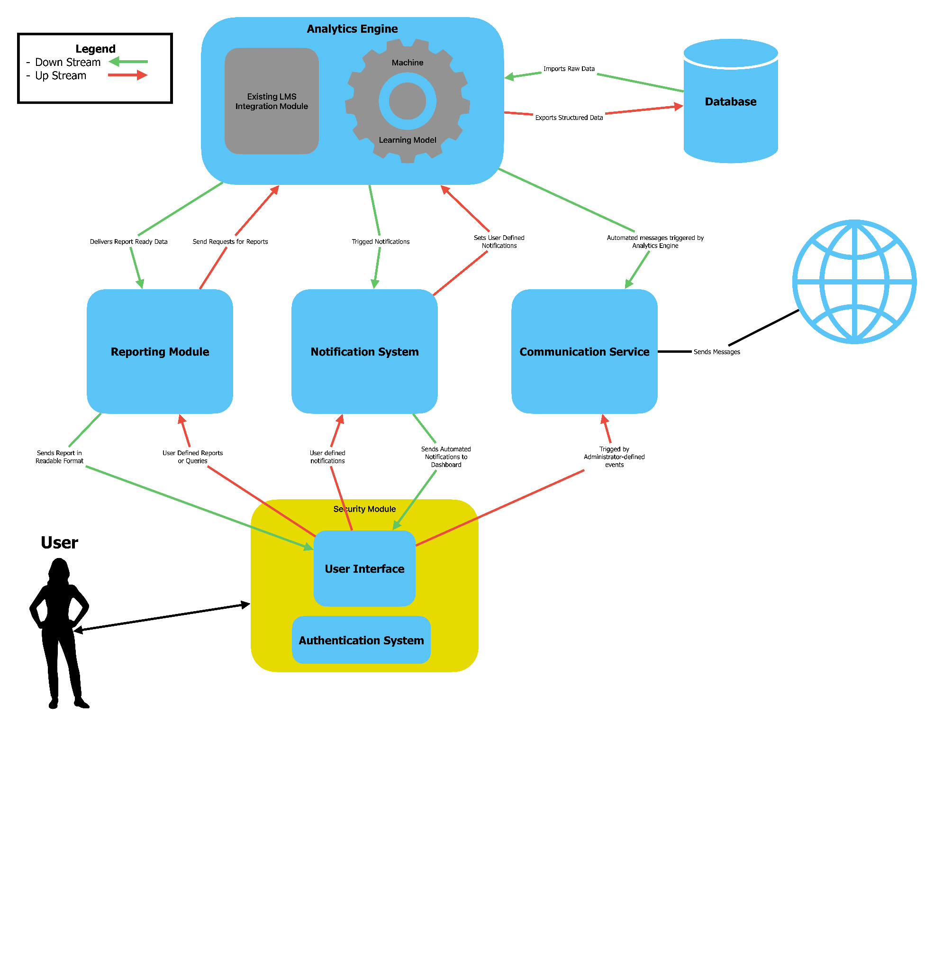

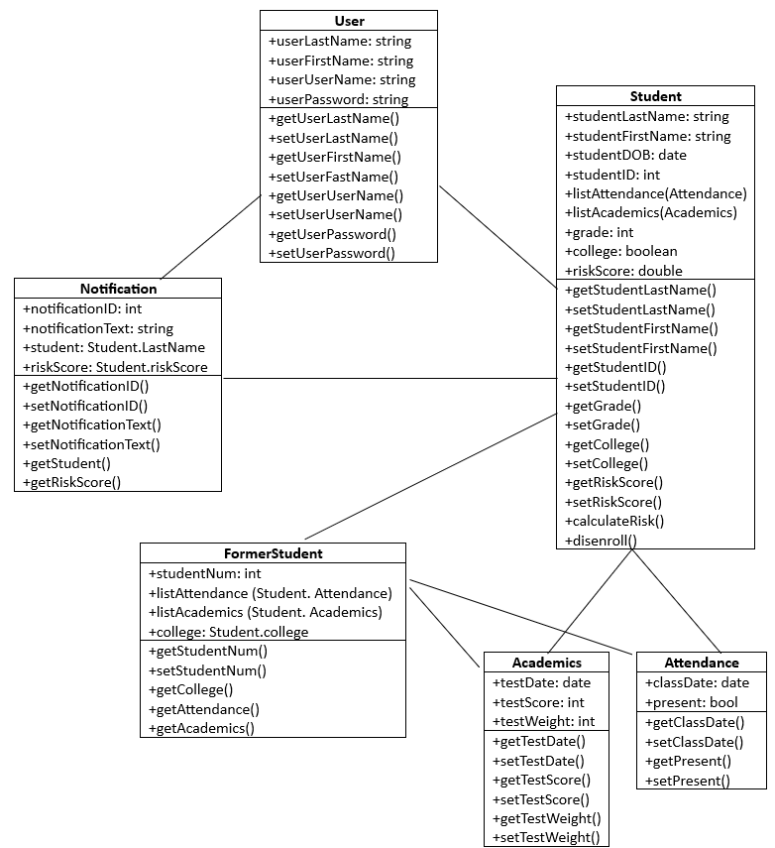

# Agile Team Formation, Responsibilities, and Implementation Iterations (schedule).

## Team Responsibilities

Adam Carrigan - Tester, Developer, Operations, Technical and Domain Expert.

James Gilligan - Architect and Technical and Domain Expert.

Cody Lepp - Subject Matter Expert, Developer, and UX Designer.

Adam Mason - Developer Ops and Stakeholder Relations.

Karen Ross - Project Manager/Scrum Master, Developer, and Developer Ops.

Dratin Wood - Developer, Developer Ops, and Stakeholder Relations.

## Iteration Plan

| **#1 Iteration** | **Week 1 - 2** |
| --- | --- |
| **Features** | **Estimated Effort (in 30-minute story points)** |
| User Registration and Authentication System | 2 |
| Data Integration and ETL Processes | 3 |
| Academic Performance Analytics Module (Grades, Coursework Progress, Standardized Test Scores) | 3 |
| Attendance and Participation Tracking System (Overall Attendance, Class Participation) | 2 |
| Behavioral and Engagement Metrics Module (Extracurricular Activities, Social Engagement, Disciplinary Records) | 3 |

| **#2 Iteration** | **Week 3 - 4** |
| --- | --- |
| **Features** | **Estimated Effort (in 30-minute story points)** |
| Learning Progress and Milestones Tracker (Curriculum Progression, Skill Development) | 3 |
| Feedback and Interaction Analytics (Teacher Feedback, Parental Involvement) | 2 |
| Psychosocial and Wellness Metrics Monitoring (Well being Measures, Social Interactions) | 2 |
| Demographic and Background Information Module (Age, Socioeconomic Background, Language Proficiency) | 2 |
| Technology and Resource Access Tracker (Access to Resources, Digital Engagement) | 2 |

| **#3 Iteration** | **Week 5 - 6** |
| --- | --- |
| **Features** | **Estimated Effort (in 30-minute story points)** |
| Post-Secondary Aspirations Tracking (College Applications, Career Planning) | 2 |
| Retention-Specific Metrics System (Enrollment Status, Enrollment Changes) | 3 |
| Risk Identification and Notification System | 3 |
| User Interface for Data Visualization | 5 |
| Student Data Management System | 3 |

| **#4 Iteration** | **Week 7 - 8** |
| --- | --- |
| **Features** | **Estimated Effort (in 30-minute story points)** |
| Performance and Scalability Optimization | 2 |
| Security and Compliance Measures | 2 |
| Parent-Teacher Collaboration Features | 2 |
| Feedback and Improvement Module | 2 |
| Documentation and Training Materials | 1 |

# Conclusion

Project Proposal Summary:

This project aims to enhance the teaching experience by leveraging automation to alleviate teachers from time-consuming tasks, enabling them to prioritize student success. The core aim is to create an analytics tool that can sift through data to identify key factors influencing student retention, such as attendance patterns, learning progress, and feedback. Analyzing these aspects provides insights into what keeps students engaged and where they face challenges. Consequently, the proposed system empowers educators to effortlessly monitor students' progress, ensuring a seamless flow of data into a centralized database for accurate progress measurement. Proactive alerts notify teachers when students approach an 'at-risk' threshold, facilitating timely interventions. The user-friendly interface simplifies the interaction, ensuring ease of use. Parents are also granted the flexibility to disenroll their students from the program at any point. The overarching goal is to streamline educational processes, fostering an environment where educators can dedicate more time to impactful teaching while maintaining a comprehensive understanding of student development.

Implementation Plan using Agile Methodology:

The team adopts an Agile approach, distributing roles to capitalize on individual strengths and fostering collaboration. Daily meetings ensure a continuous feedback loop, allowing the team to adapt to evolving project goals and workload dynamics. The development process kicks off with meticulous planning, including collaborative sessions to sketch out the application's design.

Following the planning phase, team members take on their designated roles, contributing to the development of the application. The iterative nature of Agile methodology allows for continuous refinement as the design evolves into a functional product. Rigorous testing follows the development phase, ensuring the product meets quality standards.

Upon successful testing, the product is presented to the customer for approval. Post-approval, the team proceeds to deployment, inviting end-users and stakeholders to engage with the application. This inclusive approach enables comprehensive feedback, facilitating further enhancements based on real-world usage. The project's success is gauged not only by technical standards but by the satisfaction and feedback of the end-users and stakeholders.

# List of Abbreviations

ETL - extract, transform, and load, is a data integration process that combines data from multiple data sources into a single, consistent data store that is loaded into a data warehouse or other target system

PII - personally identifiable information: information that can be used to identify a customer or user

SRT - student retention analytics tool

UX - user experience: encompasses how the user interacts with the application

# Definitions

Agnostic - denoting or relating to hardware or software that is compatible with many types of platforms or operating systems

Scrum - an agile software development method that focuses on requirements, analysis, design, evolution, and delivery